Project Title - Gods vs Mortals: Does Height Matter in the Olympics?

Team Members: Jeremy Sabio, Kasie Wong, Michael Dowlin

Project Description: This project is designed to analyze any possible correlation in height between Olympic athletes (Gods!) vs the average population (Mortals!). In addition, amongst the divine, how significant is height in determining their success in their respective event?

Research Questions to Answer:

* Are Olympians getting taller by event over time? Yes and no
* Per event, is height a significant factor for medaling? It depends. (matters for 25 events)

Abstract:

The first modern Olympic games took place in 1896 (cite source). In the last 60 years, the number of world records broken at the Olympics has exponentially increased (cite source). Globally, the average male height has drastically increased since 1896 with improvements in nutrition and standard of living across the world (cite source). As men have gotten taller over time, the question that we ask is this: ***Is this trend observed in the average Olympian height over time?***

To answer this question, we collected all available height data across all Olympic events from 1896 to 2016 (<https://www.kaggle.com/heesoo37/120-years-of-olympic-history-athletes-and-results>). We also obtained the average 18-year old male height data by country from NCD-RisC (<http://ncdrisc.org/data-downloads-height.html>).

First, we analyzed the data to see the winter vs Summer data availability. The inaugural Winter Olympics occurred in 1924, therefore less data was available. Upon review, Winter Olympics data only comprised ~18% of the total data set, thus we decided to focus on just the Summer Olympics.

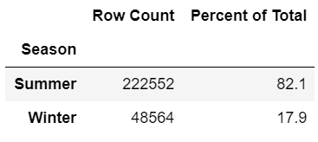

Next, we analyzed the availability of height data in the Summer data set. We found that ~23% of height data was missing from all Summer Olympic event information. We found that prior to 1960, over half of the athlete’s height data was unavailable. Thus, we decided to narrow our focus of data to post-1960.



When observing the remaining Summer Olympic post-1960 data with available height information, we found that female participation was significantly less than that of men. Women’s data comprised a mere ~33% of remaining data availability with inconsistent data availability across the Olympic years. Thus, we decided to focus on the men’s events.

Of the 16 remaining overall sports, there were 84 events with height data available across all 15 Olympics between 1960 - 2016 (e.g. the long jump event within Athletics (a.k.a. Track and Field) sport)

For our data comparison, we brought in the average global height data of 18-year-olds over time. In order to align with our Olympic data set focus, we only compared the average global height of men from 1960 - 2016.

We compared the overall male average height from 1960-2016 with that of the average Olympic height. We found that the overall global average male height increased from 1960 until it peaked in approximately 2000 before plateauing and then slowly decreasing. In contrast, we found that the average male Olympian height sharply increased in a linear fashion from 1960 - 2016.



To better understand this drastic linear increase in Olympian height over time, we further analyzed change in height over time by sport. First, we observed that basketball, rowing, and water polo had the greatest positive changes in height over time. In contrast, gymnastics, weightlifting, diving had a slight negative change in height over time. Overall, height was slowly increasing over time for Olympians across most sports.



Several sports had many sub events; these would be classified by weight class or specialized activity (e.g., light welterweight in Boxing and discus throw in Athletics). Within the Athletics sport, there were 23 unique sub events. We noticed the discus throw had a much larger increase in height over time vs the marathon.

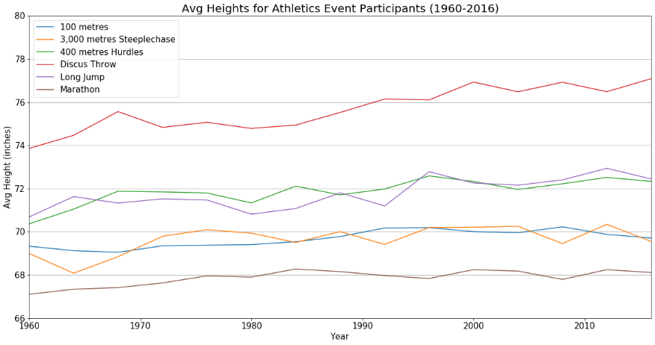

Next, for the 84 events, we tested for the significance of the mean heights for Olympians vs the global average. 82 out of the 84 sub events were found to have some significance where p was less than 0.05. The two events that were not found to have a large significance in mean height were light weight class in Boxing and Platform Diving.

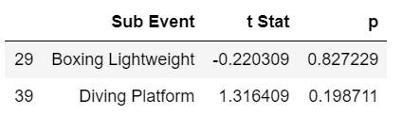

Next, we tested to see if there was significance in mean heights between medalists vs non-medalists. We found 25 events where the mean medalist height has significantly different from the mean non medalist height.

For further analysis, we created some distributions of the sub events with the lowest p-values. These were the 100-meter dash, 100-meter swim and all-around gymnastics. Finally, we plotted the distribution between the heights of medalists vs non-medalists to incorporate the latest lesson from class.

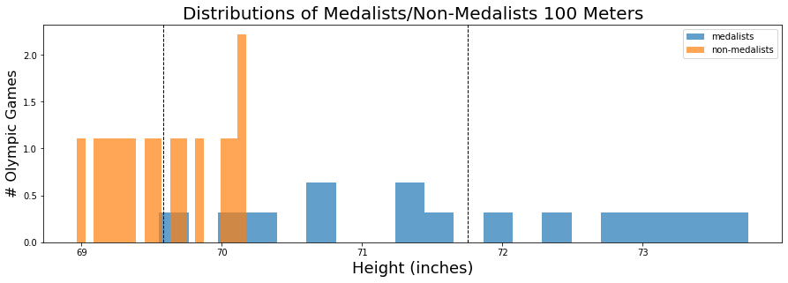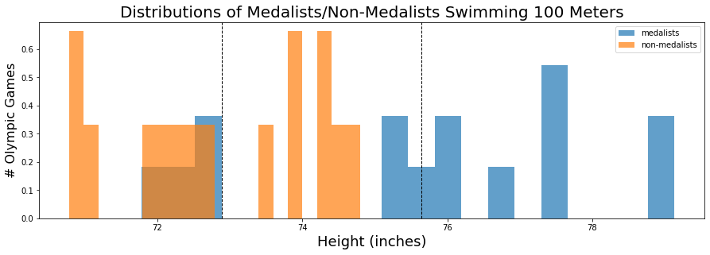

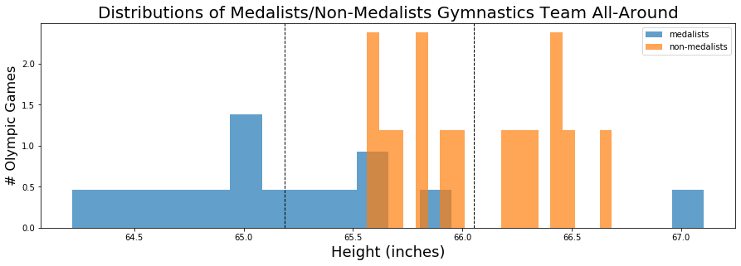

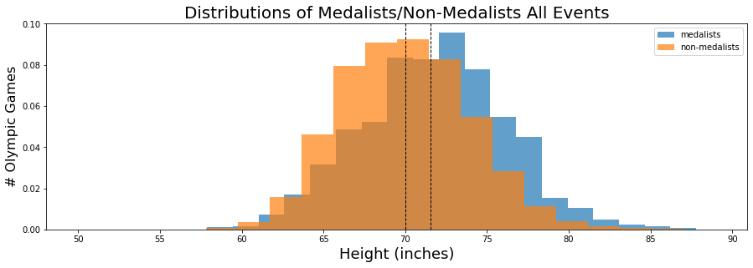

The final t-test compared a country’s average population and their respective athlete’s heights. 102 came out as statistically significant; we plotted the distributions of the top three (United States, India and Brazil) for evaluation.

